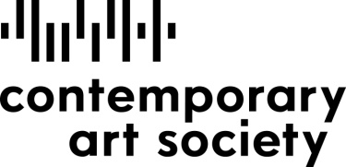

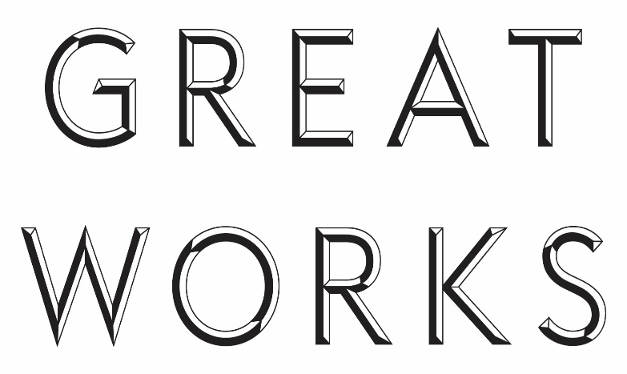
Application Form
Name of applicant:
Position within organisation:
Name of organisation:
Applicants are invited to make a case for the acquisition of a work by an artist of their choice. In composing your argument applicants are encouraged to consider the following questions:
- Describe how your chosen artist and their work connect to your existing collection, your city or region?
- How would a major acquisition through the GREAT WORKS fund benefit your audience?
- How would it develop scholarship within the museum further? How would you use it to raise the profile of your museum nationally and internationally?
- Can you describe why the acquisition of a major work through the GREAT WORKS scheme would be of particular value now?
Please do not write more than 500 words:

