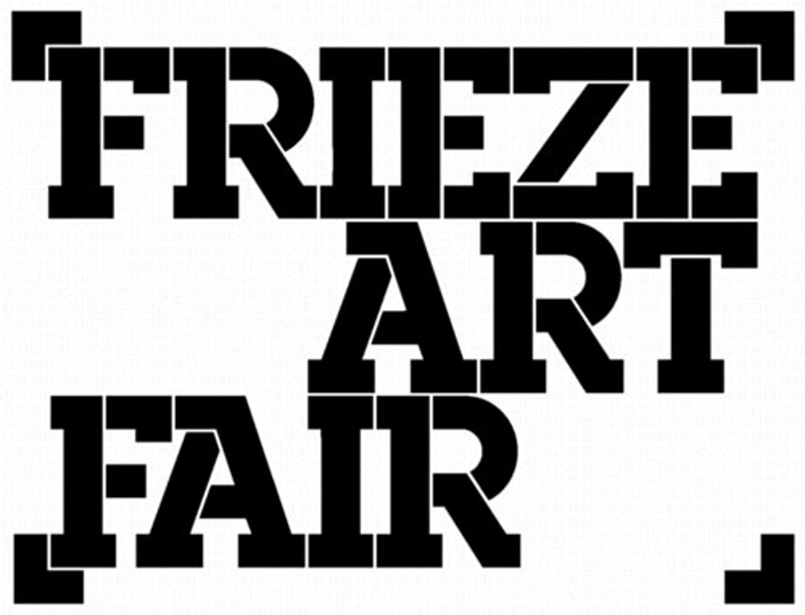

Application Form:
CAS Collections Fund at Frieze

Name of applicant: _____________________________________________
Position within organisation: _____________________________________________
Name of organisation: _____________________________________________

If you are interested in submitting an application, please answer the following questions (no more than 500 words in total):

- Please describe your particular areas of focus in developing your collection of contemporary art:

- How do you feel this scheme will support your professional development?

- Please give details of the acquisitions and/or exhibition programmes for which you have been responsible in the past:

- Can you describe why the acquisition of a major new contemporary work would be of particular value now?

- Do you have any restrictions in relation to artistic media within your collection?

We recommend a preliminary conversation with colleagues considering making an application, please contact christine@contemporaryartsociety.org to arrange a phone appointment with our Curatorial Team.

